Names: ______________
Lines and Angles
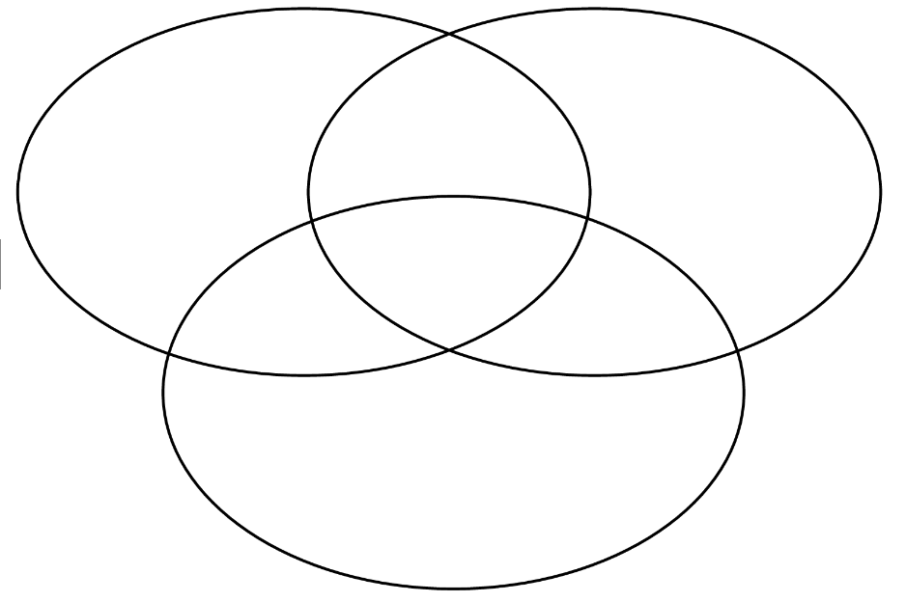
A | B | C | D | E | F | G
H | I | J | K | L | M | N
O | P | Q | R | S | T | U
V | W | X | Y | Z

