Clancy & Millie and the Very Fine House
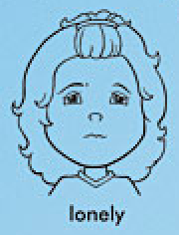
Clancy:
________________________________________________________ | ________________________________________________________ | ________________________________________________________
You:
________________________________________________________ | ________________________________________________________ | ________________________________________________________

