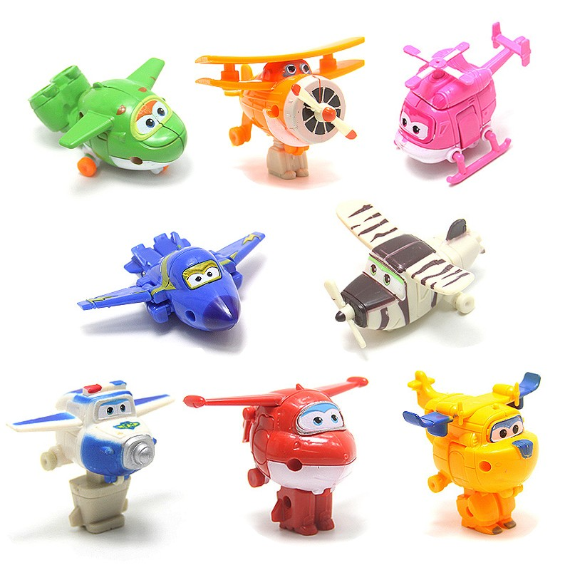
Challenge:
I have one set of toys, there are 8 altogether.
My friend asks if he can play with ¼ (one quarter) of them.
​So I give him 4 toys.
Is this correct?
Explain why or why not....

Challenge:
I have one set of toys, there are 8 altogether.
My friend asks if he can play with ¼ (one quarter) of them.
​So I give him 4 toys.
Is this correct?
Explain why or why not....

Challenge:
I have one set of toys, there are 8 altogether.
My friend asks if he can play with ¼ (one quarter) of them.
​So I give him 4 toys.
Is this correct?
Explain why or why not....

Challenge:
I have one set of toys, there are 8 altogether.
My friend asks if he can play with ¼ (one quarter) of them.
​So I give him 4 toys.
Is this correct?
Explain why or why not....

