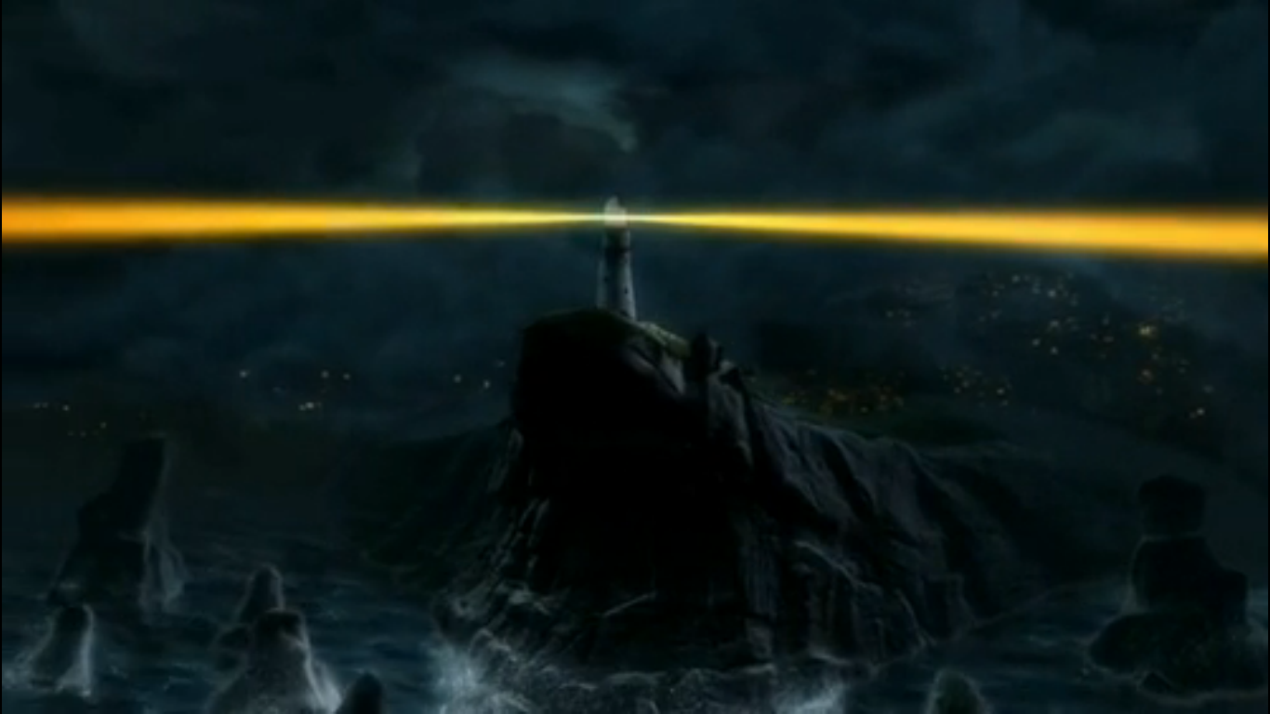

Language to describe setting:

Think about: the time, the weather, the physical environment, sounds, smells, feelings.

Questions to ask the Lighthouse Keeper

The Lighthouse Keepers Answers

