Number:  __ __ __ | Number:  __ __ __
Expanded Notation: | Expanded Notation:
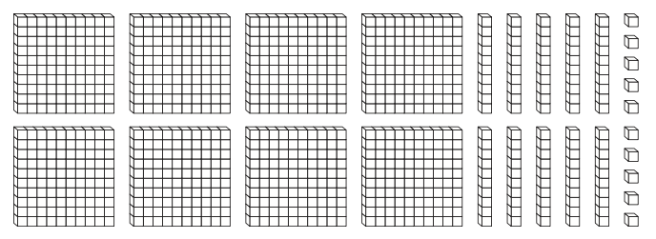
Next 3 numbers…  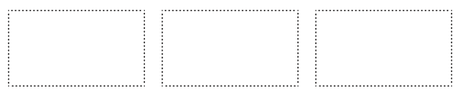 | Next 3 numbers…
Words: | Words:
Number:  __ __ __ | Number:  __ __ __
Expanded Notation: | Expanded Notation:
Next 3 numbers… | Next 3 numbers…
Words: | Words:

