One ant has six legs, how many legs do three ants have?  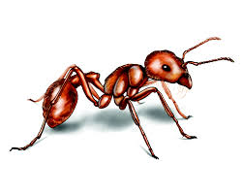 | 1 crab 10 legs, how many legs do 4 crabs have?  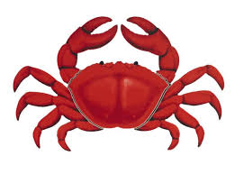
If each box has 3 oranges, how many oranges are needed for 5 boxes? | A starfish has 5 legs, how many legs for 6 starfish?
If each child has half a slice of bread each, how many slices are needed for four people? | 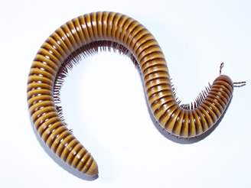  A millipede has 100 legs, how many legs for 3 millipedes? (Don’t draw this!)
One ant has six legs, how many legs do three ants have? | 1 crab 10 legs, how many legs do 4 crabs have?
If each box has 3 oranges, how many oranges are needed for 5 boxes? | A starfish has 5 legs, how many legs for 6 starfish?
If each child has half a slice of bread each, how many slices are needed for four people? | A millipede has 100 legs, how many legs for 3 millipedes? (Don’t draw this!)

