Australia
Using the image provided what do you…….. | Using descriptive language (adjectives) write your sentence reflecting the senses. | Poem
See  Rocks, hills, orange, huge. | I can see …….  I can see orange, rocky hills that go forever. | I can see orange, rocky hills that go forever.  I can hear squawking eagles searching for prey.  I can smell eucalyptus trees after it rains.  I can feel warm desert sun kissing my skin.  I enjoy discovering new interesting parts of Australia.
Hear  Eagle, swooping, squawking | I can hear…….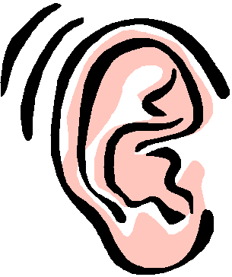  I can hear the squawking of eagles searching for prey.
Smell  Eucalyptus trees, rain, damp, | I can smell ……  I can smell eucalyptus trees after the rains.
Touch  Hot, sun, burning skin, hat, cool clothing | I can feel …….  I can feel the hot desert sun on my skin.
Think  Exploring, discovering, interesting, new places, new people, | I think…..  I enjoy ……  I wonder ……  I want to discover…..  I enjoy discovering new interesting parts of Australia.

Australia
Using the image provided what do you…….. | Using descriptive language (adjectives) write your sentence reflecting the senses. | Poem
See | I can see …….
Hear | I can hear…….
Smell | I can smell ……
Touch | I can feel …….
Think | I think…..  I enjoy ……  I wonder ……  I want to discover…..

