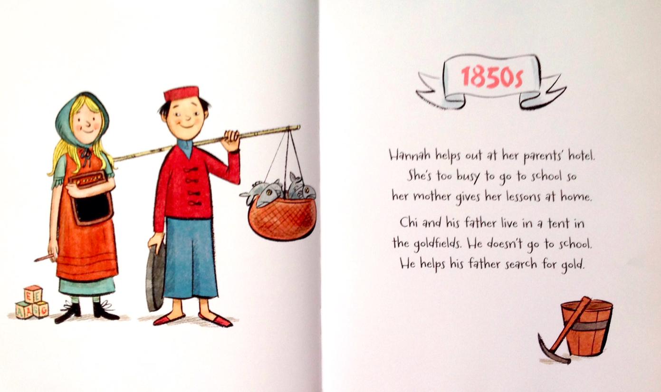 |  |  |  | 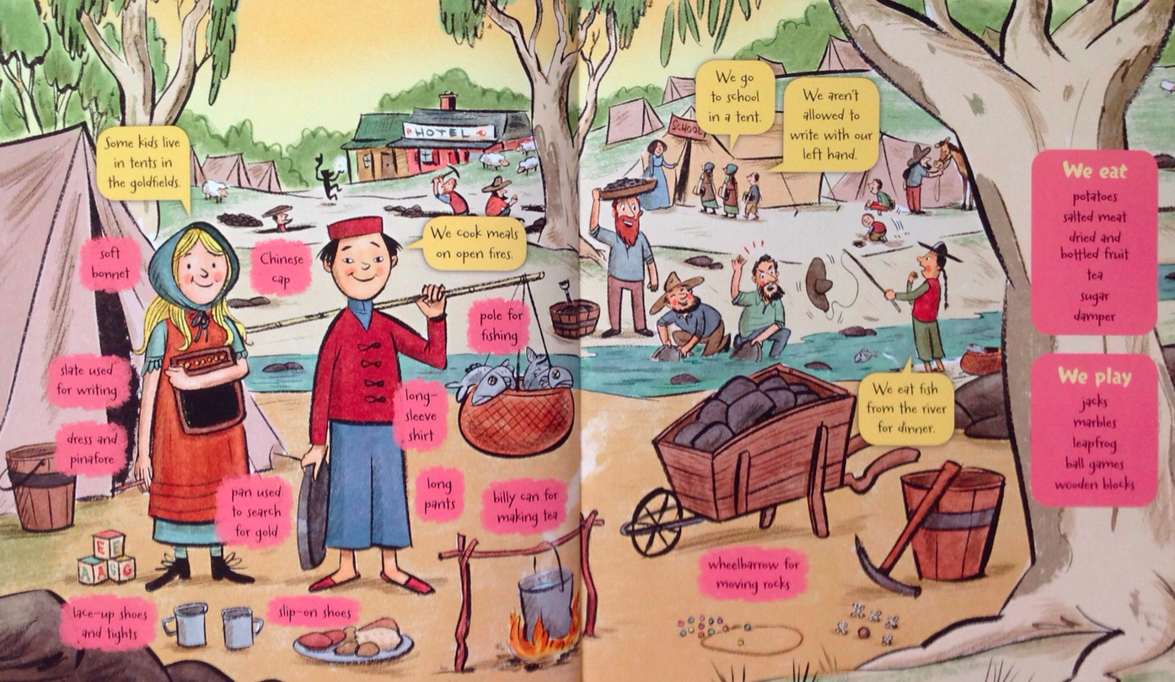
Factual information | Diagram | Highlighted Text | Bullet Points | Part of a Timeline | Title | Subheading | Quotations
Circle an example of the following text features you can see…
Explain the setting:
Explain the time/date:
Explain what you know about the characters:

