Time – Problem Solving
Start Time 3:30pm | Travel for 2 hours 15 minutes |  | Finish time quarter past four | Started 3 hours, 15 minutes earlier
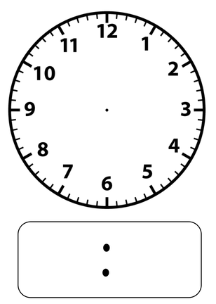
Start time 15 minutes before six o’clock | Rode my bike for 45 minutes. |  | Movie finished at ten thirty in the morning | Movie was 90 minutes in length, what time did it start?
Make your own two questions for a peer to complete…

