Timelines
 | 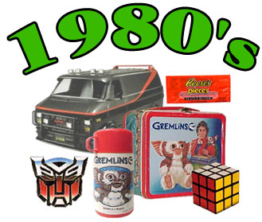
Draw something you see: | Draw something you see:
Write at least three (3) things that you are informed about: | Write at least three (3) things that you are informed about:

